**ANALYSIS REPORT**

**Parameter:**

Following Sigma’s has been used in all the 3 parts:

Sigma = [0.001, 0.01, 0.05, 0.08, 0.1, 0.3, 0.5,0.7, 0.8, 1, 2, 3, 4, 5, 7, 8, 10, 13, 15, 18]

*[NOTE: After 18-20, accuracies for all parts were coming constant]*

*Part (1): Using all points in the training set as centers for the RB Function*

*(FYI: Complete Outputs (All Accuracies and MSE) are available in Submitted Code File)*

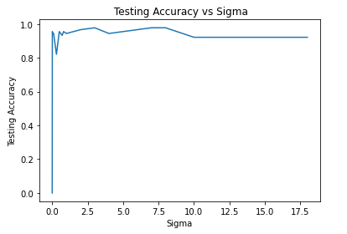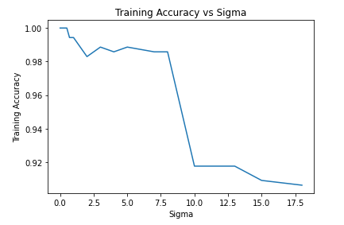

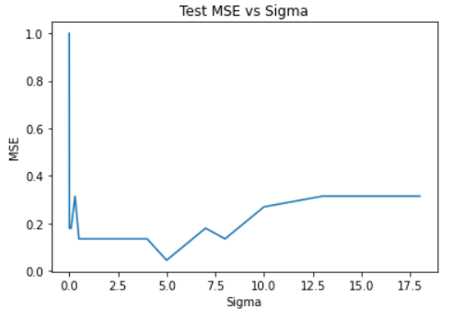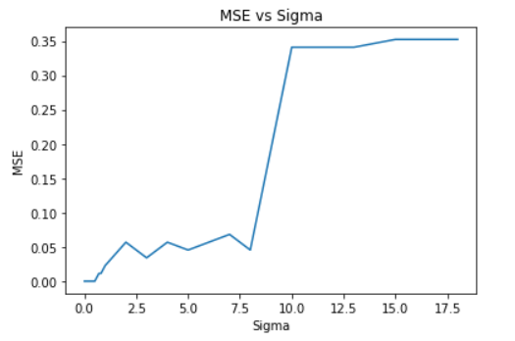

*Training Analysis:*

* Best Training Accuracy of 99.71% is obtained in the range of sigma = 0.7 because of good interpolation at higher widths. i.e. close to the real gaussian curve.
* After 0.5, Training Accuracy has been decreased slightly till sigma =8, after which sudden decrement in accuracy is observed.
* Range of Mean Square Error: [0 – 0.375]

*Testing Analysis:*

* Best Testing Accuracy has been observed at sigma = [3, 7, 8]
* Range of Mean Square Error: [0.089 – 1.00]
* Minimum Mean Square Error 0.034 has been observed at accuracies 3, 7, 8, reason being approximation by RBF Function could be identical or real close to real curve.
* Less Accuracy has been observed for initial sigma’s because of poor interpolation at lower widths.
* Overfitting case might be observed at Sigma = [0.001 – 0.05], where for training we have 100% accuracy with 0 MSE and for testing we received 0% accuracy with 1 MSE.

*Part (2A): Using 150 random centers from input data for the RB Function*

*(FYI: Complete Outputs (All Accuracies and MSE) are available in Submitted Code File)*

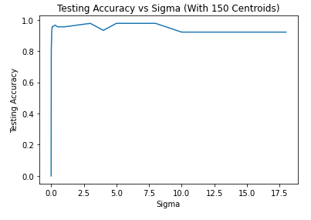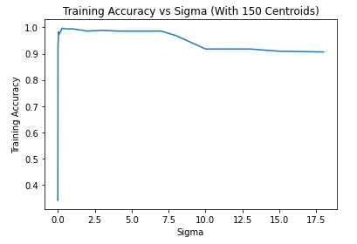

*Training Analysis:*

* Best Training Accuracy of 99.715% is obtained for Sigma = 0.3 with Mean Square Error = 0.011
* For initial sigma’s, training accuracy has been increased drastically i.e. from sigma 0.001 to 0.05, after which accuracy remained approximately between 98 - 99% till sigma =8, where after steep decrease in accuracy from 97 to 91% has been observed.

*Testing Analysis:*

* Best Testing Accuracy of 97.75% is obtained for Sigma = 3, 5, 7, 8 with Mean Square Error = 0.089
* Significant increase in accuracy for initial sigma’s till 0.1, after which accuracy remained in the range of approximately 96-97% and starts decreasing after sigma =8.

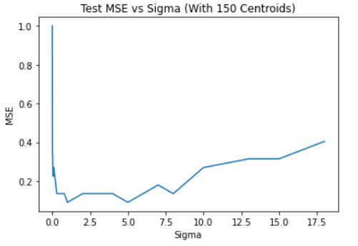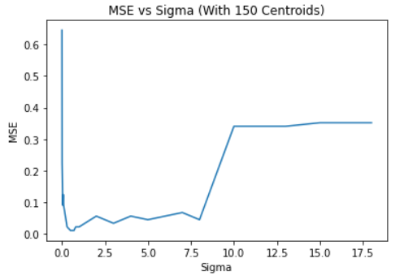

*Part (2B): Using 150 random centers from KMeans Algorithm for the RB Function*

*(FYI: Complete Outputs (All Accuracies and MSE) are available in Submitted Code File)*

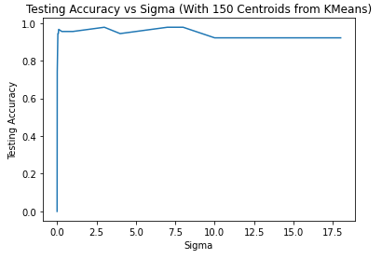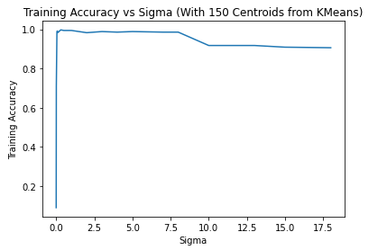

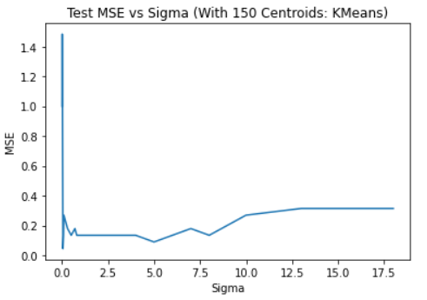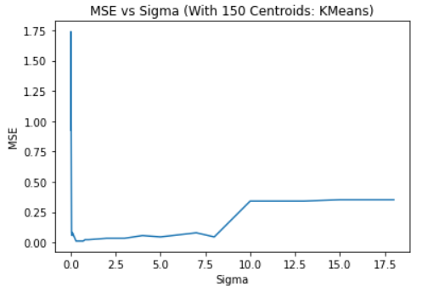

*Training Analysis:*

* Maximum Training Accuracy is 99.715% at sigma = 0.3, 0.5 and 0.7, with MSE = 0.011.
* Training Accuracy faces a steep increase with the increase in initial sigma (0.001, 0.01, 0.05) *(Red Highlighted)*

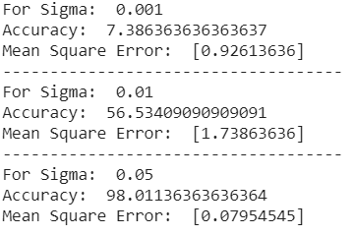

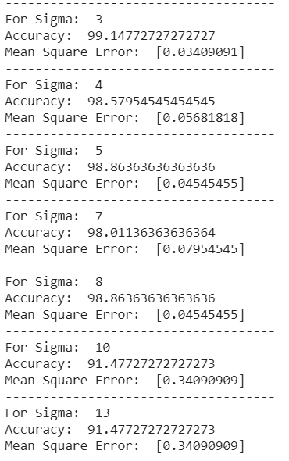

* Accuracy starts drooping after sigma = 3 and steep decrement occurred from sigma = 10. *(Blue Highlighted)*

*Testing Analysis:*

* Maximum Testing Accuracy is 98.87% at sigma = 0.05, with MSE = 0.044, i.e. at lower sigma higher width has been obtained leading to better interpolation as compared to other sigma values.
* Testing Accuracy also faces steep increase with the increase in initial sigma (0.001, 0.01, 0.05) (*Red Highlighted*)
* During the mid range of sigma, Accuracy fluctuated between approximately 94-97%.
* During the last sigma values, accuracy become constant at 92.13%.

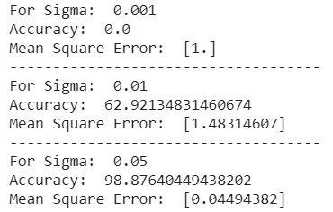

*Final Remarks:*

* Sigma 3 can be considered as optimal sigma since one of the highest accuracies has been observed for the same, i.e. curve created by RBF NN is close to the real gaussian curve.
* On comparing all three cases, it is observed that taking 150 random centroids has shown the best optimal accuracy with minimum sigma as compared to taking all 441 centroids.